Super Compound Sentences!
1/2 W students have been working on producing compound sentences. We worked with a partner and had to produce a sentence that identifies who and what is in the picture, what they are doing and where they are doing it. We chose a character from a picture in the book called “The Swap”. Below are our super sentences and colouring in.

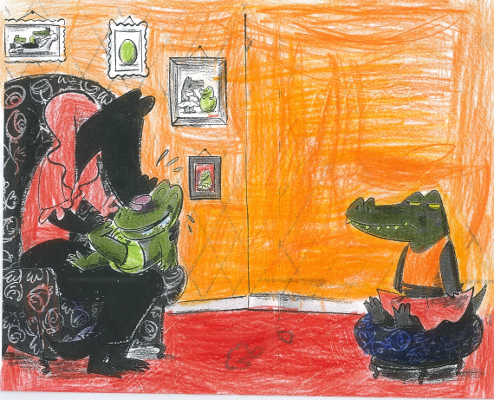
Mother crocodile is kissing baby crocodile on the beautiful flowery couch. Jaya & Jade

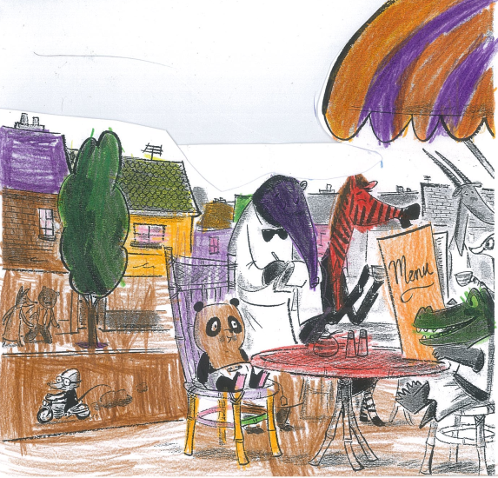
The big sister is telling her baby panda brother what to eat at the restaurant. Kayden T.
The baby panda is having lunch at the café. Ekam & Daman
Caroline the crocodile is waiting for her food at the café. Imojen & Kobe

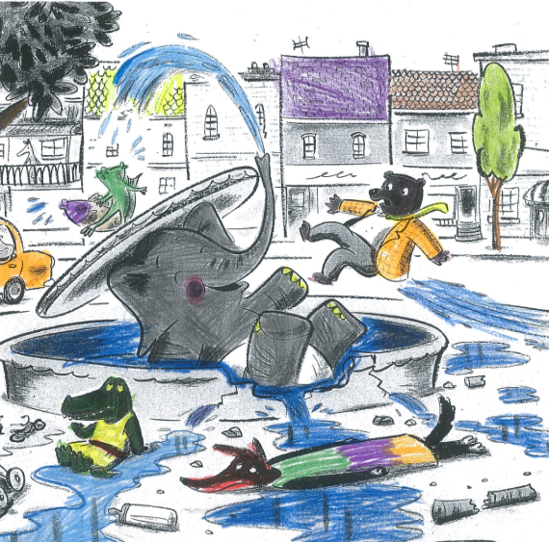
The baby elephant is squirting water in the fountain at the park. Kayden W & Rihanna
The baby elephant is trashing the water fountain in the middle of the city.
Noah & Daman
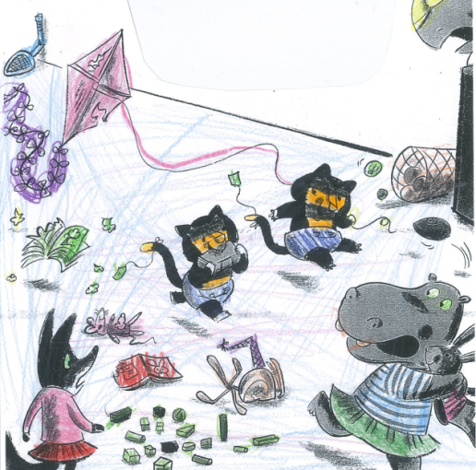
The twin tigers are ruining the toys and chewing the book in the toy shop. Eeooleah
The twin tigers were destroying the toys in the toy shop. Yuddaki & Shakayah
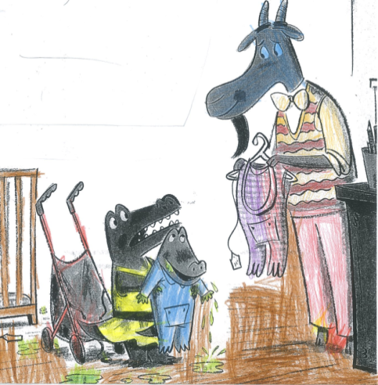
The baby crocodile is dribbling on the floor inside the baby shop. Quade & Jundawarra
Caroline and her baby brother are talking to the shop assistant in the baby shop.
Jaya & Melinda
Caroline the big sister is going to change the baby at the baby shop. Keira & Braxon

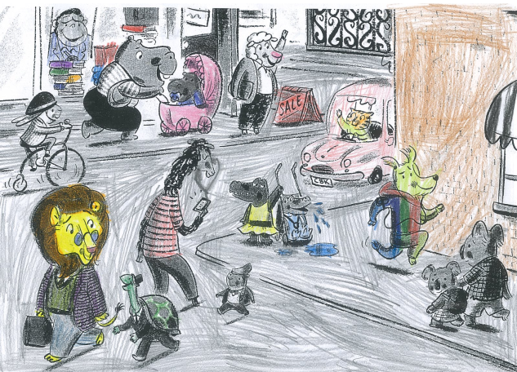
The baby crocodile is dribbling on the footpath in the middle of the busy town. Ronin & Noah
The man sheep is waving to his friend in the city. Miller & Allan
The big sister is taking her new baby for a walk in town. Hosea & Troy

